**Introduction**

**Online shopping** is a form of [electronic commerce](https://en.wikipedia.org/wiki/Electronic_commerce) which allows consumers to directly buy [goods](https://en.wikipedia.org/wiki/Good_(economics)) or [services](https://en.wikipedia.org/wiki/Service_(economics)) from a seller over the [Internet](https://en.wikipedia.org/wiki/Internet) using a [web browser](https://en.wikipedia.org/wiki/Web_browser) or a [mobile app](https://en.wikipedia.org/wiki/Mobile_app). Consumers find a product of interest by visiting the [website](https://en.wikipedia.org/wiki/Website) of the retailer directly or by searching among alternative vendors using a [shopping search engine](https://en.wikipedia.org/wiki/Shopping_search_engine), which displays the same product's availability and pricing at different e-retailers. As of 2020, customers can shop online using a range of different computers and devices, including [desktop computers](https://en.wikipedia.org/wiki/Desktop_computer), [laptops](https://en.wikipedia.org/wiki/Laptop), [tablet computers](https://en.wikipedia.org/wiki/Tablet_computer) and [smartphones](https://en.wikipedia.org/wiki/Smartphone).

An online shop evokes the physical analogy of buying [products](https://en.wikipedia.org/wiki/Product_(business)) or services at a regular ["bricks-and-mortar"](https://en.wikipedia.org/wiki/Brick_and_mortar_business) [retailer](https://en.wikipedia.org/wiki/Retailing) or [shopping center](https://en.wikipedia.org/wiki/Shopping_center); the process is called business-to-consumer (B2C) online shopping. When an online store is set up to enable businesses to buy from another businesses, the process is called [business-to-business](https://en.wikipedia.org/wiki/Business-to-business) (B2B) online shopping. A typical online store enables the customer to browse the firm's range of products and services, view photos or images of the products, along with information about the product specifications, features and prices.

Online stores usually enable shoppers to use "search" features to find specific models, brands or items. Online customers must have access to the Internet and a valid [method of payment](https://en.wikipedia.org/wiki/Online_shopping#Payment) in order to complete a transaction, such as a [credit card](https://en.wikipedia.org/wiki/Credit_card), an [Interac](https://en.wikipedia.org/wiki/Interac" \o "Interac)-enabled [debit card](https://en.wikipedia.org/wiki/Debit_card), or a service such as [PayPal](https://en.wikipedia.org/wiki/PayPal). For physical products (e.g., paperback books or clothes), the e-tailer ships the products to the customer; for digital products, such as [digital audio files](https://en.wikipedia.org/wiki/Digital_audio_file) of [songs](https://en.wikipedia.org/wiki/Song) or [software](https://en.wikipedia.org/wiki/Software), the e-tailer usually sends the file to the customer over the Internet. The largest of these online retailing corporations are [Alibaba](https://en.wikipedia.org/wiki/Alibaba_Group), [Amazon.com](https://en.wikipedia.org/wiki/Amazon.com), and [eBay](https://en.wikipedia.org/wiki/EBay).

**ER DIAGRAM, SCHEMA DIAGRAM**

This chapter of the report describes the structure of the project, followed by Entity Relationship Diagram, Schema Diagram and the table structures.

**ER Diagram with relationships and cardinality ratio**

An entity relationship model*,* also called an entity-relationship (ER) diagram*,* is a graphical representation of entities and their relationships to each other, typically used in computing in regard to the organization of data within databases or information systems. An entity is a piece of data-an object or concept about which data is stored.

The cardinalit*y* or fundamental principle of one data aspect with respect to another is a critical feature. The relationship of one to the other must be precise and exact between each other in order to explain how each aspect links together. In simple words Cardinality is a way to define the relationship between two entities.

The following are the notations of the ER diagram:

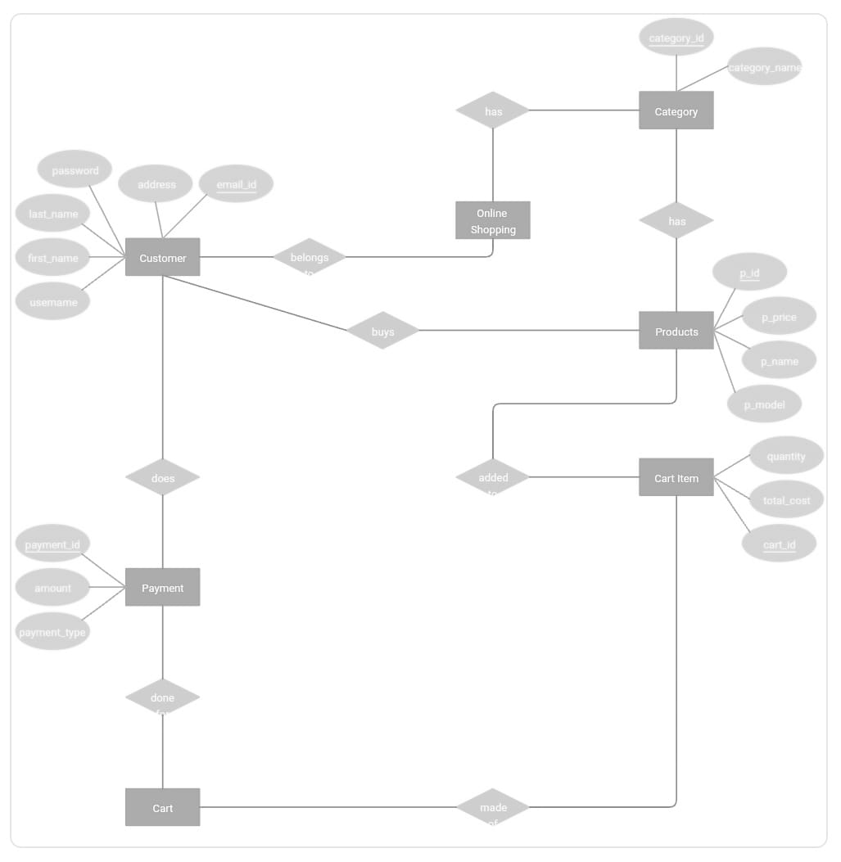

**Relational Database**

A relational database is a collection of data items with pre-defined relationships between them. These items are organized as a set of tables with columns and rows. Tables are used to hold information about the objects to be represented in the database. Each column in a table holds a certain kind of data and a field stores the actual value of an attribute. The rows in the table represent a collection of related values of one object or entity. Each row in a table could be marked with a unique identifier called a primary key, and rows among multiple tables can be made related using foreign keys. This data can be accessed in many different ways without reorganizing the database tables themselves.



**TABLE SCREEN SHOTS**

WEEK 1:

In the context of SQL, data definition or data description language (DDL) is a syntax for creating and modifying database objects such as tables, indices, and users.

● CREATE to create a new table or database.

● ALTER for alteration.

● Truncate to delete data from the table.

● DROP to drop a table.

● RENAME to rename a table.

**Product**

SQL> create table product (product_id int,product_name varchar(30),price number(5),product_typevarchar(30));

Table created.

SQL> desc product;

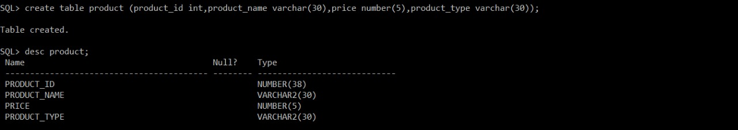

**Customer**

SQL> create table customer (user_id int,email varchar(30),password varchar(30),customer_namevarchar(30),phone_number number(10),address varchar(50));

Table created.

SQL> desc customer;

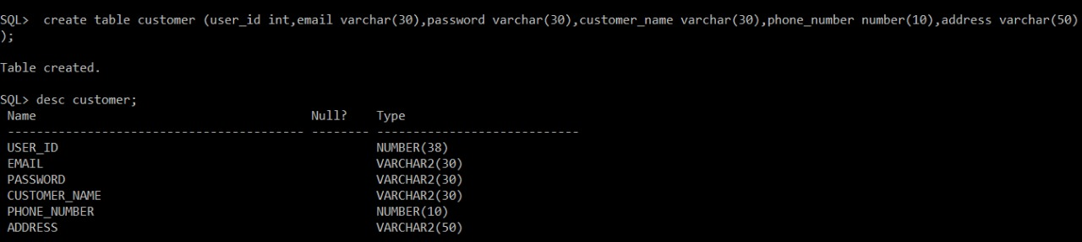

**Seller**

SQL> create table seller (seller_id int,seller_name varchar(30),seller_address varchar(50),rating number(2),phone_number number(10));

Table created.

SQL> desc seller;

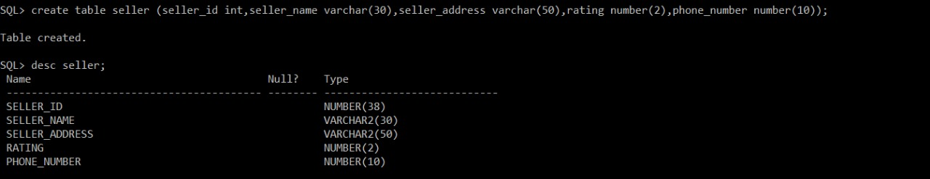

**Payment**

SQL> create table payment(product_id int,amount number(5),payment_type varchar(20),promo_code varchar(10),status varchar(20));

Table created.

SQL> desc payment;

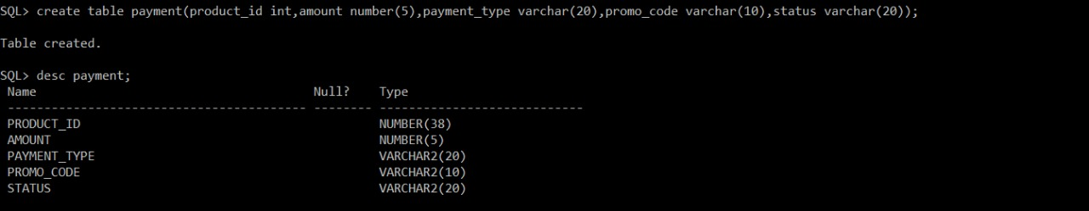

**Orders**

SQL> create table orders (order_id int,ordered_date date,no_of_items number(3),customer_id int,price number(5),delivery_status varchar(20));

Table created.

SQL> desc orders;

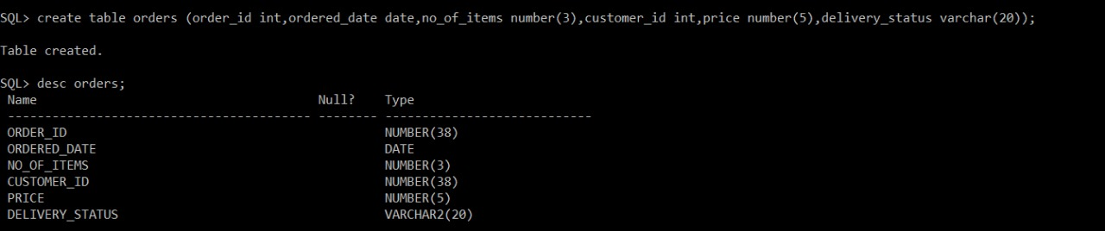

**Courier**

SQL> create table courier(address varchar(20),phone_number number(10),weight number(5),delivery_type varchar(20),courier_name varchar(20));

Table created.

SQL> desc courier;

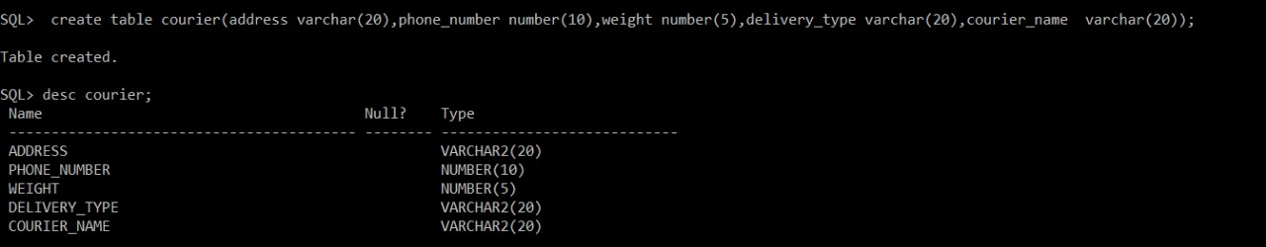

SQL> alter table seller modify(Expected_price number(5));

Table altered.

SQL>descseller;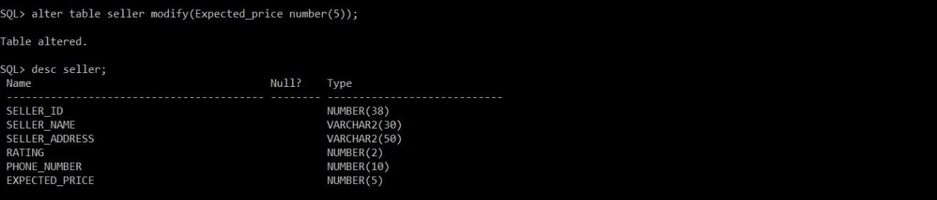

**WEEK 2:**

A data manipulation language (DML) is a computer programming language used for adding (inserting), deleting, and modifying (updating) data in a database.

● INSERT – is used to insert data into a table.

● UPDATE – is used to update existing data within a table.

● DELETE – is used to delete records from a database table

SQL>Insertintoproducts values(&product_id,'&product_name',&price,'&product_type');

Enter value for product_id: 01

Enter value for product_name: Lux

Enter value for price: 30

Enter value for product_type: cosmetic

old1:Insertintoproductsvalues(&product_id,'&product_name',&price,'&product_type')

new 1: Insert into products values(01,'Lux',30,'cosmetic')

1rowcreated.

SQL> /

Enter value for product_id: 02

Enter value for product_name: earpods

Enter value for price: 1000

Enter value for product_type: electronic

old1: Insert into products values(&product_id,'&product_name',&price,'&product_type')

new 1: Insert into products values(02,'earpods',1000,'electronic')

1 row created.

SQL> /

Enter value for product_id: 03

Enter value for product_name: song tv

Enter value for price: 25000

Enter value for product_type: electronic

old1:Insert into products values(&product_id,'&product_name',&price,'&product_type')

new 1: Insert into products values(03,'song tv',25000,'electronic')

1 row created.

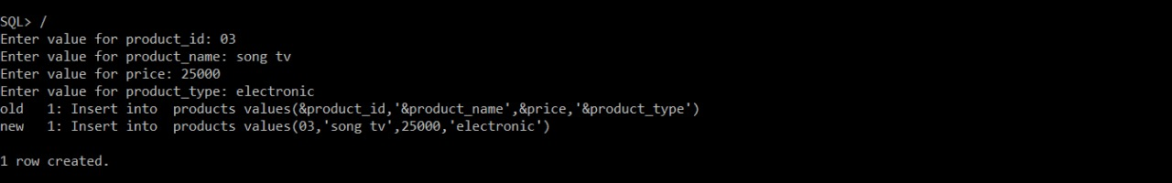

Enter value for product_id: 04

Enter value for product_name: scorpion helmet

Enter value for price: 3999

Enter value for product_type: intuitive

old1:Insertinto products values(&product_id,'&product_name',&price,'&product_type')

new 1: Insert into products values(04,'scorpion helmet',3999,'intuitive ')

1 row created.

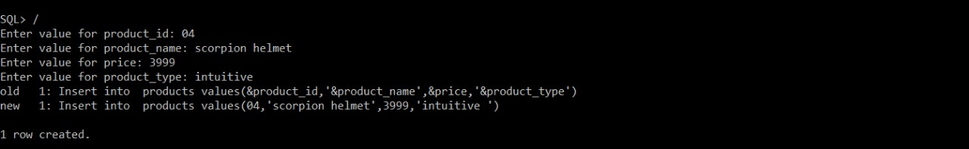

SQL> select * from products;

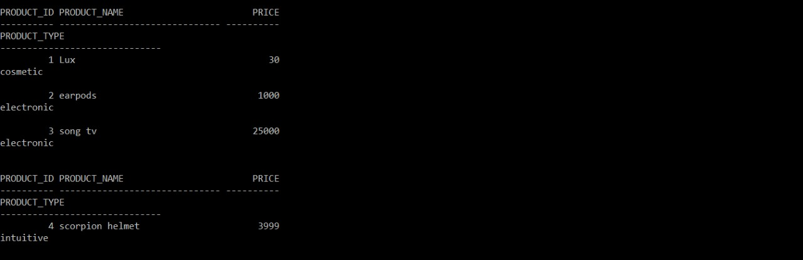

SQL> _

Enter value for product_id: 01

Enter value for amount: 20

Enter value for payment_type: UPI

Enter value for promo_code:

Enter value for status: FAILED

old 1: insert into payment values(&product_id,&amount,'&payment_type','&promo_code','&status')

new 1: insert into payment values(01,20,'UPI',' ','FAILED')

1 row created.

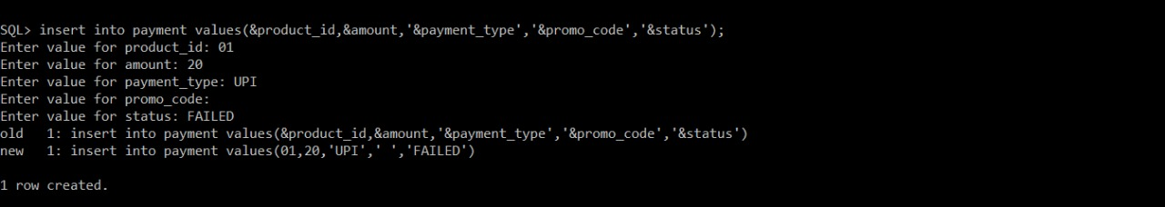

SQL> /

Enter value for product_id: 02

Enter value for amount: 1000

Enter value for payment_type: cashondelivery

Enter value for promo_code:

Enter value for status: SUCCESS

old 1: insert into payment values(&product_id,&amount,'&payment_type','&promo_code','&status')

new 1: insert into payment values(02,1000,'cashondelivery',' ','SUCCESS')

1 row created.

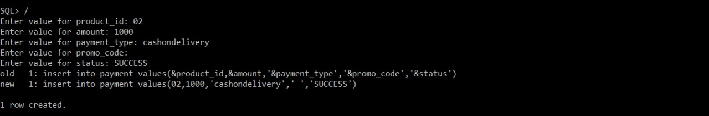

SQL> /

Enter value for product_id: 03

Enter value for amount: 25000

Enter value for payment_type: UPI

Enter value for promo_code: HAPPY

Enter value for status: SUCCESS

old 1: insert into payment values(&product_id,&amount,'&payment_type','&promo_code','&status')

new 1: insert into payment values(03,25000,'UPI','HAPPY','SUCCESS')

1 row created.

SQL> /

Enter value for product_id: 04

Enter value for amount: 3999

Enter value for payment_type: cashondelivery

Enter value for promo_code: JOURNEY

Enter value for status: SUCCESS

old 1: insert into payment values(&product_id,&amount,'&payment_type','&promo_code','&status')

new 1: insert into payment values(04,3999,'cashondelivery','JOURNEY','SUCCESS')

1 row created.

SQL> select * from payment;

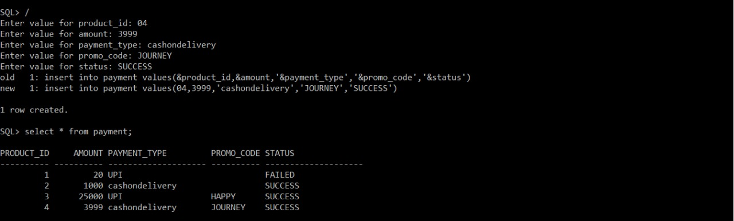

SQL> update payment set status = 30 where status='FAILED';

1 row updated.

SQL> select * from payment;

SQL> insert into payment values(05,50000,'UPI','LUCKY','SUCCESS');

1 row created.

SQL> select * from payment;

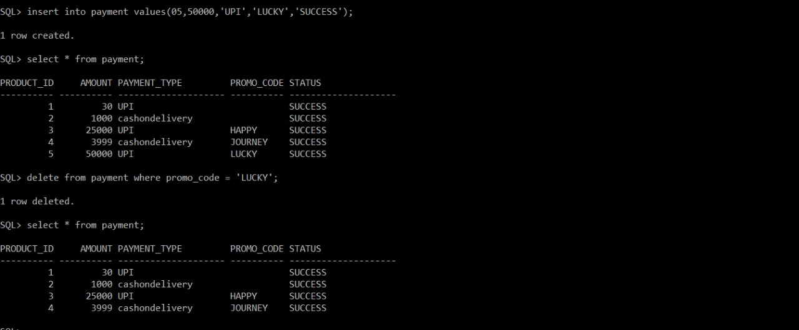

**WEEK 4(TCL)**

SQL> select * from payment;

PRODUCT_ID AMOUNT PAYMENT_TYPE PROMO_CODE STATUS

---------- ---------- -------------------- ---------- --------------------

1 30 UPI SUCCESS

2 1000 cashondelivery SUCCESS

3 25000 UPI HAPPY SUCCESS

4 3999 cashondelivery JOURNEY SUCCESS

SQL> commit;

Commit complete.

SQL> update payment set amount=2000 where product_id=2;

1 row updated.

SQL> select * from payment;

PRODUCT_ID AMOUNT PAYMENT_TYPE PROMO_CODE STATUS

---------- ---------- -------------------- ---------- --------------------

1 30 UPI SUCCESS

2 2000 cashondelivery SUCCESS

3 25000 UPI HAPPY SUCCESS

4 3999 cashondelivery JOURNEY SUCCESS

SQL> rollback;

Rollback complete.

SQL> select * from payment;

PRODUCT_ID AMOUNT PAYMENT_TYPE PROMO_CODE STATUS

---------- ---------- -------------------- ---------- --------------------

1 30 UPI SUCCESS

2 1000 cashondelivery SUCCESS

3 25000 UPI HAPPY SUCCESS

4 3999 cashondelivery JOURNEY SUCCESS

SQL> savepoint s1;

Savepoint created.

SQL> delete from payment where amount = 3999;

1 row deleted.

SQL> select * from payment;

PRODUCT_ID AMOUNT PAYMENT_TYPE PROMO_CODE STATUS

---------- ---------- -------------------- ---------- --------------------

1 30 UPI SUCCESS

2 1000 cashondelivery SUCCESS

3 25000 UPI HAPPY SUCCESS

SQL> rollback to s1;

Rollback complete.

SQL> select * from payment;

PRODUCT_ID AMOUNT PAYMENT_TYPE PROMO_CODE STATUS

---------- ---------- -------------------- ---------- --------------------

1 30 UPI SUCCESS

2 1000 cashondelivery SUCCESS

3 25000 UPI HAPPY SUCCESS

4 3999 cashondelivery JOURNEY SUCCESS

**WEEK 5(SQL CONSTRAINT)**

***Products***

SQL> create table products (product_id int not null,product_name varchar(30)not null,price number(5) not null,product_type varchar(30) not null,primary key(product_id));

Table created.

SQL> desc product;

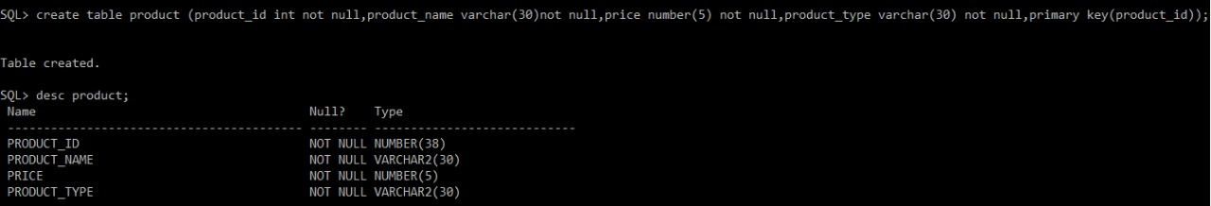

***Customer***

SQL> create table customer (user_id int not null,email varchar(30) not null unique,password varchar(30) not null,customer_name varchar(30) not null,phone_number number(10) not null unique,address varchar(50) not null);

Table created.

SQL> desc customer;

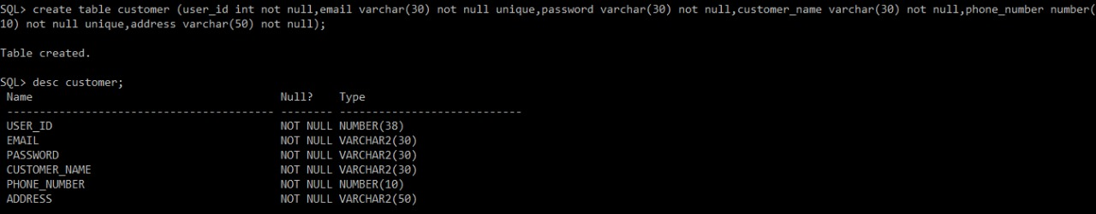

***Seller***

SQL> create table seller (seller_id int not null,seller_name varchar(30) not null,seller_address varchar(50) not null,rating number(2) not null,phone_number number(10) not null,primary key(seller_id));

Table created.

SQL> desc seller;

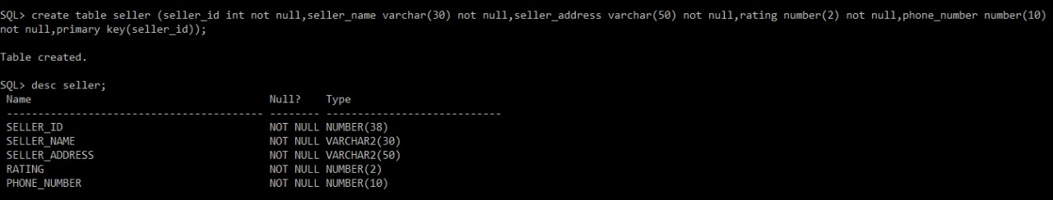

***Payment***

SQL> create table payment(product_id int not null,amount number(5) not null,payment_type varchar(20) not null,promo_code varchar(10) not null,status varchar(20) not null,foreign key(product_id) references products(product_id));

Table created.

SQL> desc payment;

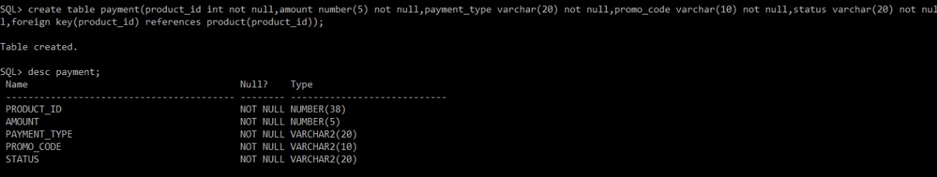

create table orders (order_id int not null,ordered_date date not null,no_of_items number(3) not null,customer_id int not null,price number(5) not null,delivery_status varchar(20) not null,primary key(order_id));

Table created.

SQL> desc orders;

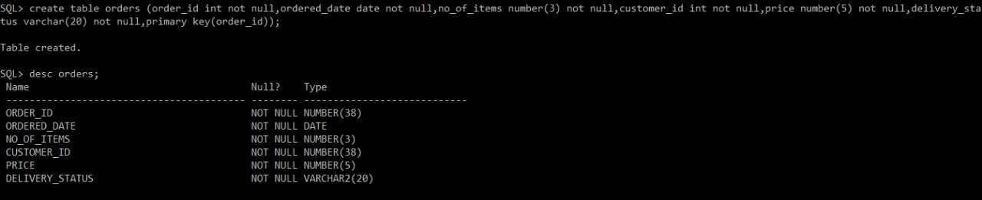

***Courier+***

SQL> create table courier(address varchar(20) not null,phone_number number(10) not null unique,weight number(5) not null,delivery_type varchar(20)not null,courier_name varchar(20) not null);

Table created.

SQL> desc courier;

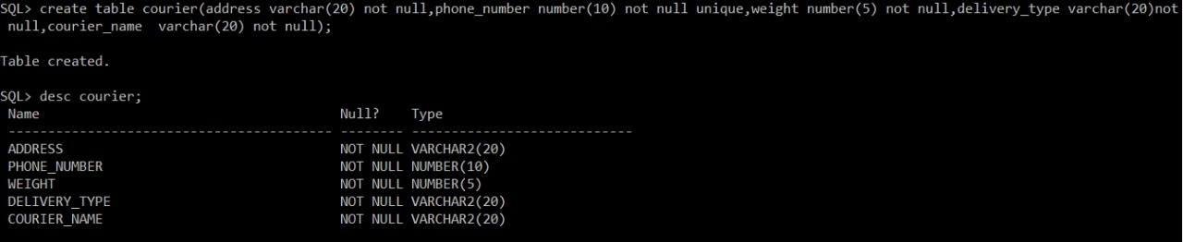

WEEK 6 (INBUILT FUNCTION)

SQL> select upper(product_name) from products;

UPPER(PRODUCT_NAME)

------------------------------

LUX

EARPODS

SONG TV

SCORPION HELMET

SQL> select lower(payment_type) from payment;

LOWER(PAYMENT_TYPE)

--------------------

upi

cashondelivery

upi

cashondelivery

SQL> select lpad(product_name,20,'*' ) from products;

LPAD(PRODUCT_NAME,20,'*')

--------------------------------------------------------------------------------

*****************Lux

*************earpods

*************song tv

*****scorpion helmet

SQL> select rpad(product_name,20,'*' ) from products;

RPAD(PRODUCT_NAME,20,'*')

--------------------------------------------------------------------------------

Lux*****************

earpods*************

song tv*************

scorpion helmet*****